Concepts for Process Industries

Case study referring to Chapter 8 of  
“Integral Logistics Management – Operations and Supply Chain Management Within and Across Companies”, 5th ed.

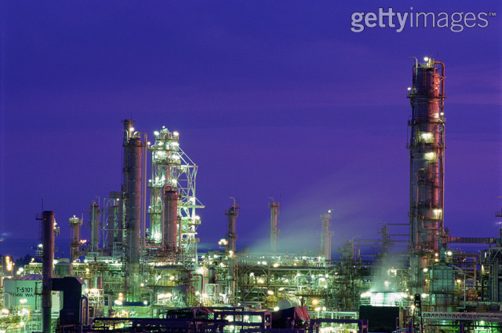

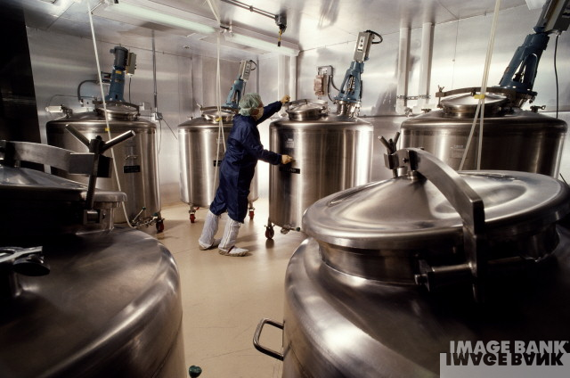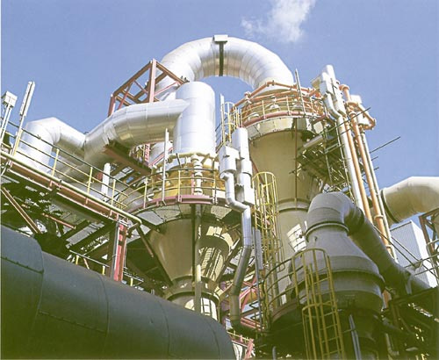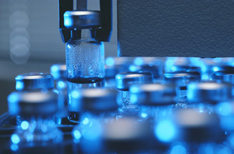

Name, prename: ______________________________________________

Name, prename: ______________________________________________

Name, prename: ______________________________________________

Name, prename: ______________________________________________

Please send to: 🡺 Paul.Schoensleben@ethz.ch

1. Introduction

### 1 Objectives

In contrast to companies with convergent product structure (discrete manufacture) production settings, a glance at the basic process industries in which, for example, oil, natural gas, coal, energy or steel are produced and/or processed, makes clear that the production structure has a considerable influence on both production infrastructure and layout. This entails special circumstances that must be considered in operations and supply chain management. Processor-oriented production actually brings up questions that have no equivalent in discrete manufacturing. Thus, the case study has the following intended learning outcomes:

* + - Recognize and explain the essential differences between the most common processor-oriented industries and convergent product structure production
    - Give a clear indication of the special problems of the process industry that affect planning and products as well as costs determination and allocation

Prerequisites for this case study are chapter 8 of the book *Integral Logistics Management,* or the corresponding Course 8 under <https://www.opess.ethz.ch/>.

### 1.2 Submission

The assigned tasks indicate what is to be handed in. We expect a professionally worked out solution report as a basis for the top management’s decision-making. We further expect a clear reasoning in complete sentences, i.e. not just with keywords. The total length of the report must not exceed eight pages We suggest the use of a spreadsheet calculation program. .xls objects are embedded in this word-document.

__________________________________________________________________________

# 2. Case Study

#### Exercise 1: Characteristics of production in process industries

List and explain (briefly!) the essential characteristics of process industries. Go into, among other things, the distinctive features of the production structure and possible production concepts, and give appropriate examples.

#### Exercise 2: Batches

In the process industries, it is differentiated between discontinuous and continuous *production. In the case of discontinuous production, batches and campaigns are com*mon terms that characterize this kind of production.

a) Give a comprehensive definition of the terms batch and campaign.

b) When and why would one use a batch or a campaign in production? When would a use of continuous flow production be more appropriate?

c) Name a typical product for both production concepts from the fields of energy, chemistry or life sciences, etc.

#### Exercise 3: Use of cycles in production planning

The following sketch shows a part of the process of chocolate production in a discontinuous operation.

Recipe: R1: 200 kg chocolate, 50 kg hazelnuts and 50 kg flavoring per batch

R2: 100 kg chocolate, 150 kg broken chocolate, 25 kg hazelnuts and

25 kg flavoring per batch

The numbers at the arrows stand for each required or accrued amount of the materials or products. The addition of accrued broken chocolate is based on an experience value that must be considered as a fixed size per batch. The devices for adding flavoring and for mixing are able to handle any constraining changes related to weight and volume that occur with a change of recipe.

a) What amount of chocolate, flavoring and hazelnuts are needed to produce 4000 kg of packaged hazelnut chocolate, when no broken chocolate is added before the flavoring phase (recipe 1)? Remember that, based on the preparation capacity, a certain minimum amount per batch is required (e.g., for flavoring according to Recipe 1: 250 kg / per batch).

b) Now consider the addition of broken chocolate (recipe 2) and calculate the required amount of chocolate, flavoring and hazelnuts needed to produce 500 kg of packaged hazelnut chocolate.

#### Exercise 4: Cost calculation

Based on the process scheme in Exercise 3, the following costs and market prices can be assumed for the production and sale of chocolate:

|  |  |  |  |
| --- | --- | --- | --- |
|  |  |  |  |
| **Costs** |  |  |  |
|  |  | Sales price / costs | Unit |
| Raw chocolate |  | 10.00 | CHF / kg |
| Flavoring |  | 17.00 | CHF / kg |
| Hazelnuts |  | 500.00 | CHF / **50 kg** |
| Flavoring process |  | 25.00 | CHF / batch |
| Mixing and filling |  | 35.00 | CHF / batch |
| Packaging |  | 0.18 | CHF / **100 g** |
|  |  |  |  |
| **Market prices** |  |  |  |
|  |  | Sale Price | Unit |
| Hazelnut chocolate |  | 2.50 | CHF / **100 g** |
| Broken chocolate |  | 5.00 | CHF / kg |
|  |  |  |  |

Assume each of the following exercises is one single process run. The corresponding amounts used can be taken directly from the scheme in Exercise 3.

1. First determine the costs of the chocolate production including packaging for a process run based on Recipe 1. Show the various possibilities for assign the costs to main and by-products (at least three different variants). Evaluate these variants with respect to their information value.
2. You now have two fundamental alternatives – sale or processing - for the use of broken chocolate in chocolate manufacturing. What consequences do these alternatives have on profit or loss? What would you recommend to a manufacturer? Consider as well the possible effects on product quality!

#### Exercise 5: Planning in process industries

You are responsible for production planning in a pharmaceutical company. Currently, you are working on next year's plan for the active substances A and B. The sequence of processing raw materials and semi-finished products is shown by the sketch below.

The figure shows the various product steps for active substances A and B at their defined capacity centers, whose names (GRx) you should not confuse. This comes from an actually existing production process and was only modified slightly.

In addition to the respective capacity center names, the batch sizes are given in kilograms (input amount), with the yield (output) as a percentage of the input amount, along with the maximum number of batches that can be produced per week (capacity).

**Hint:** To improve your understanding of the model process - and make the exercise a bit easier, you can assume that phases K1, LINH2 and DMPC, for example, should be treated as reaction steps in which the materials added will be chemically changed. In contrast, operations SBR and CIB4 could be interpreted as processes in which the main product is separated from any by-products and waste materials, but is not chemically altered. This explains how, for example, semi-finished product ZW A* from SBR and semi-finished product ZW A from LINH2 can both be processed at capacity center DMPC. This is useful when ZW A* is chemically identical to ZW A but has a higher purity level than ZW A, which may not be absolutely necessary for processing active substance B in capacity center DMPC. When considering steps GR 2, GR 4, GR 6 and GR 7, you can assume that it is a process that serves in preparation for storage or product packaging, for example, through drying or division into portions, etc.

Consider the above explanation of the model process merely as a suggestion for your own interpretation of the process phases and not as authentic. **However, it is of essential importance is that the illustration on page 7 has no bill of material or mass balance character. Instead, it represents the required process steps from the raw materials to the end product from the point of view of the material flow.** The capacity center SBR is thus a component of the process run for both active substances. (Changeover required!)

Start your production planning with the following rules:

* Only integer values of the batch sizes can be produced.
* Semi-finished products cannot be passed on batch-wise, i.e., a following processing step can only begin when the total product amount from the previous capacity center is available.[1]*)
* Storage capacity of sufficient size is available for each process step.
* Changeover times for product changes are about 2 weeks per capacity center.
* Please base the reservation times for the individual capacity centers on full weeks (no planning on daily basis).
* Dilution is no solution.

**Questions to answer:**

1. What consequences do the technical batch sizes have in general regarding production planning? What are the consequences for storage capacity?
2. The sales volume for next year will be predicted on the basis of 10t of active substance B and 40t for active substance A. At the end of June, 20t of active substance A will be needed and the remaining 20t at the end of December. The availability date for active substance B has not yet been fixed.

Determine the earliest point of time (calendar week) for the availability of 10t of active substance B. Assume that, up until now, enough of semi-finished product B (ZW B) is on hand in the store of the process step DMPC. In addition, calculate the minimum amount required of semi-finished products A (ZW A) and B (ZW B) that must be available in order to fulfill the production goals.

**Hint:** First, plan the production based on the planning tables in Appendices 1 & 2 (These Excel templates are also available online). Naturally, you can also create your own Excel table (Take note of the batch sizes!).

1. Can the production of 10t of active substance B be completed by the end of the year if no semi-finished products A and B are available? What alternative solutions do you see? Please provide a revised schedule of the campaign planning based on you alternative solution.
2. What effect would the downtime of capacity center SBR have on the production amounts within the planning time frame and what would be the effect of an unplanned breakdown (e.g., kettle fire)? A qualitative argument will suffice.

What counter measures are appropriate from your point of view? Also consider preventive measures!

___________________________________________________________________

### Appendix 1: Planned production quantities for active substances A and B



### Appendix 2: Planning sheet for work center reservations

1. *) Example: For 10,000 kg of active substance B, you must produce 27 batches on GR6 – that corresponds to an output of 27 batches on GR2, which requires 14 weeks production time. Only in the 15th week after the start of production on GR2, can production begin on GR6. You can find this problem in practice, for example, where the work centers are at different production locations and the goods must be transported by train or tanker.